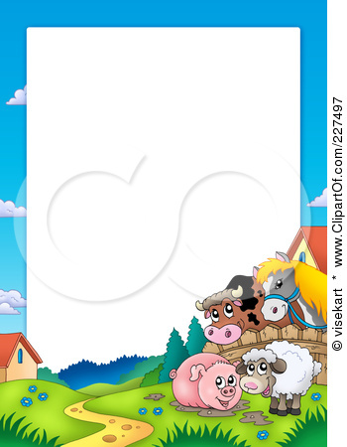

Children's Menu

Served with Peas or Beans

Battered Cod Goujons & Chips

**Pizza, Coleslaw & Chips**

Ham, Egg & Chips

**Scampi & Chips**

Burger In A Bun & Chips

**Lasagne, Garnish & Garlic Bread**

Jacket Potato & Cheesey Beans

**Chicken Goujons & Chips**

Sausage & Chips

**Chicken Curry + Rice**

All £6.95